Meta Title
Kamakhya Temple Darshan Timings & History
Meta Description
Explore Kamakhya Temple darshan timings, history & travel info in Guwahati. Plan your visit to this sacred Shakti Peetha for divine blessings.
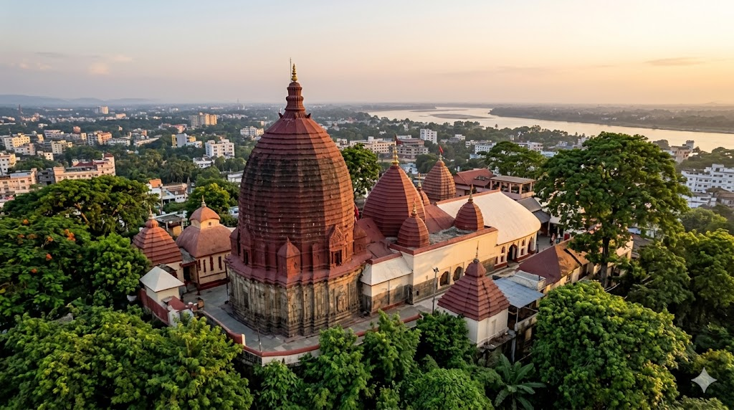

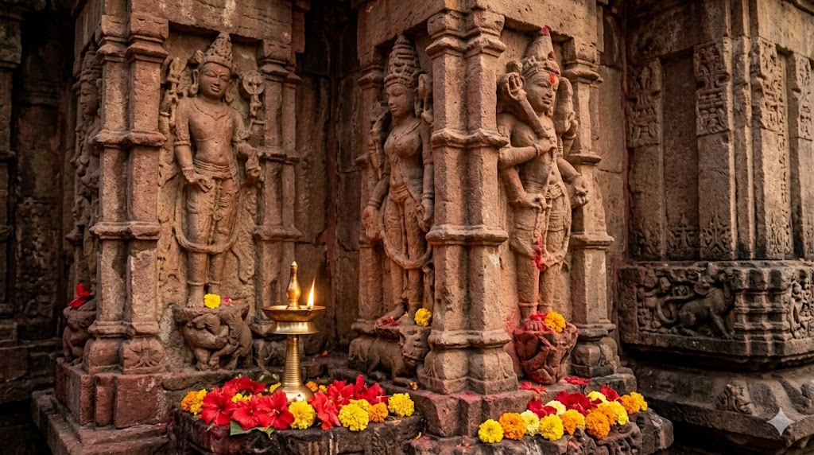

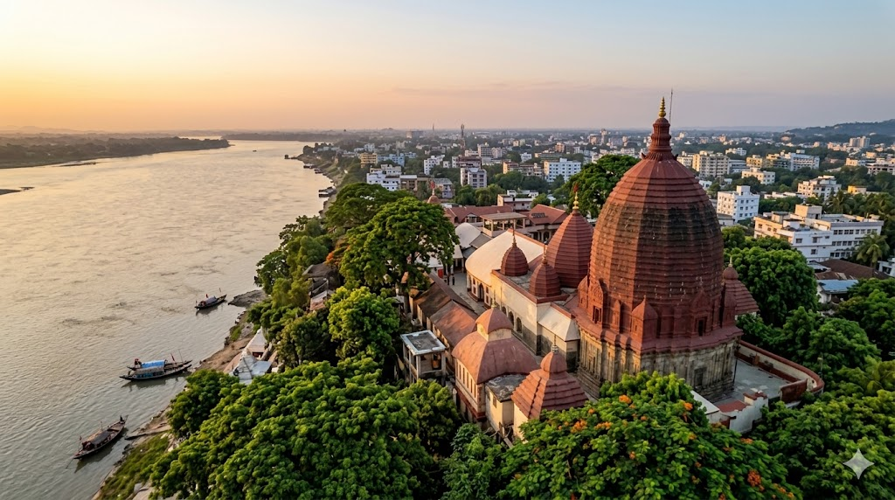

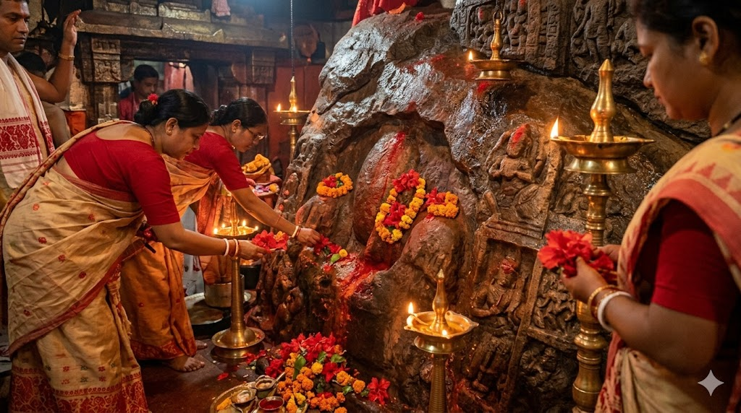

Kamakhya Temple - Darshan Timings, History & Temple Information
Experience the primal, awe-inspiring energy of the Supreme Mother at the sacred Kamakhya Temple, situated atop the mystical Nilachal Hill in Guwahati, Assam. Revered as one of the oldest and most powerful of the 51 Shakti Peethas in India, this temple is the ultimate epicenter of Tantric worship and devotion to the Goddess of Desire.
Begin your journey to the Mother's womb with expert guidance. Avoid the physical exhaustion of massive queues, complex temple protocols, and logistical hurdles with our meticulously planned travel assistance.
👉 [Click here to book your Assisted Kamakhya Darshan & Travel Package]

Kamakhya Temple – Quick Info
- Location: Nilachal Hill, Guwahati, Assam
- Deity: Maa Kamakhya (The Bleeding Goddess / Goddess of Desire)
- Significance: The supreme Shakti Peetha where the Yoni (womb/vulva) of Goddess Sati is believed to have fallen.
- Unique Feature: There is no idol or image of the deity. The Goddess is worshipped in the form of a stone Yoni from which a natural underground spring constantly flows.

The Story of Kamakhya Temple – The Origin of Shakti
The history of the Kamakhya Temple is a profound and emotionally stirring tale of cosmic love, grief, and the feminine divine. According to ancient Hindu scriptures, when Goddess Sati immolated herself in the sacrificial fire of her father Daksha’s yagna, a devastated Lord Shiva carried her burning body and performed the Tandava (the dance of destruction).
To save the universe, Lord Vishnu used his Sudarshan Chakra to dismember Sati’s body into 51 pieces, which fell across the Indian subcontinent, creating the Shakti Peethas. The most sacred part—her Yoni (womb)—fell on the Nilachal Hill. Because this represents the cosmic womb of creation, Kamakhya is celebrated as the mother of all life.
The temple is also world-famous for the annual Ambubachi Mela, during which the Goddess is believed to undergo her annual menstrual cycle. The temple remains closed for three days, and the waters of the Brahmaputra River are said to turn red.
Understanding this divine history transforms your visit into a deeply spiritual passage. When you touch the sacred waters of the natural spring, you are receiving the ultimate blessing of the Mother of the Universe.
👉 [Let us make your Assam Pilgrimage effortless. Explore our complete Travel Packages]
Devotees deeply believe that:
- A darshan of Maa Kamakhya fulfills the deepest desires (Kamana) of the heart.
- Special poojas performed here remove black magic, evil eyes, and severe astrological doshas.
- The red cloth (Rakta Vastra) received as prasad brings immense protection and prosperity.

Kamakhya Temple Darshan Timings & Daily Schedule
Note: The temple experiences heavy footfalls daily. Darshan is paused during the afternoon for the deity's rest and Bhog.
Ritual / Darshan | Timing (Approximate) | Notes
Temple Gates Open | 5:30 AM | Snana (Bathing) of the Pithasthana
Nitya Pooja | 6:00 AM | Regular morning prayers
General Darshan Begins | 8:00 AM – 1:00 PM | Open for devotees
Temple Closure (Bhog) | 1:00 PM – 2:30 PM | Sanctum closed for food offering and rest
Temple Reopens | 2:30 PM | Afternoon session begins
Evening Darshan | 2:30 PM – 5:30 PM | Open for all devotees
Evening Aarti | 5:30 PM | Sunset prayers outside the sanctum
Temple Closes | 6:00 PM | Temple doors closed for the night
Best Time for Darshan: Early morning is ideal, though securing an official Special Darshan pass is highly recommended to avoid the standard 4 to 6-hour waiting lines.
👉 [Secure your Special Darshan timing and local assistance with Vandan Darshan]

Festivals & Best Time to Visit
The Nilachal Hill vibrates with intense devotion during:
- Ambubachi Mela (June): The most significant festival celebrating the Goddess's menstruation. Millions of Tantriks, Sadhus, and devotees gather here.
- Navratri / Durga Puja (Sept/Oct): Celebrated with immense grandeur, elaborate poojas, and animal sacrifices (a traditional aspect of Shakta worship).
- Manasha Puja: A major festival dedicated to the Serpent Goddess.
Best Time to Visit:
- October to April: The weather in Assam is cool, pleasant, and perfect for exploring the hill and surrounding temples.

How to Reach Kamakhya Temple
- By Air: Lokpriya Gopinath Bordoloi International Airport (GAU) in Guwahati is approximately 20 km away.
- By Train: Kamakhya Railway Station (KYQ) is just 6 km away, while Guwahati Station (GHY) is 8 km away.
- By Road: Easily accessible via taxis and auto-rickshaws from the base of Nilachal Hill.
👉 [Need an Airport pickup or a premium Guwahati taxi? Book comfortable travel with Vandan Darshan]

Hotels & Nearby Sacred Places
Stay Options:
- Budget lodges near the Kamakhya railway station and at the base of the hill.
- Premium Luxury Hotels and Resorts in Guwahati city offering scenic views of the Brahmaputra.
Nearby Spiritual & Tourist Spots:
- Umananda Temple: A beautiful Shiva temple located on Peacock Island in the middle of the Brahmaputra River.
- Navagraha Temple: An ancient temple dedicated to the nine celestial bodies, situated on Chitrachal Hill.
- The Dasa Mahavidya Temples: Ten smaller temples dedicated to the ten forms of the Goddess, located around the main Kamakhya complex.

Plan Your Darshan
Planning your pilgrimage to the Supreme Mother? Ensure your family members travel safely and navigate the complex crowd protocols comfortably.
With Vandan Darshan, you can book:
- Guided Special Darshan (VIP Entry) & Priest Coordination
- Tantric Poojas, Kumari Puja, and Dosha Nivaran
- Travel, AC Taxi & Comfortable Hotel Stays in Guwahati
- Complete Assam & Meghalaya Spiritual Tour Packages
[Click Here to Visit our Dedicated Kamakhya Darshan Booking & Travel Services Page]

Info & FAQs – Kamakhya Temple
Where is Kamakhya Temple located?
The temple is situated on the Nilachal Hill in the western part of Guwahati, the capital city of Assam.
Why is Kamakhya Temple famous?
It is famous as the oldest and most powerful of the 51 Shakti Peethas, marking the spot where Goddess Sati's womb fell. It is the epicenter of Tantric Hinduism and is famous for the Ambubachi Mela.
Is there an idol inside the temple?
No. There is no idol or image of the Goddess. She is worshipped in the form of a yoni-shaped stone cleft in the bedrock, kept moist by a natural underground spring.
What is the dress code for Kamakhya Temple?
While there is no strict mandate like in South Indian temples, devotees are advised to wear modest, respectful traditional attire (Sarees, Salwar Kameez, Kurtas, or formal trousers).
How much time is required for Darshan?
In the free general queue, darshan can take anywhere from 4 to 8 hours. With official Special/VIP Darshan passes, the time is reduced to 1.5 to 2.5 hours.
How can I arrange my Guwahati Temple Tour easily?
You can pre-book your complete itinerary—including airport/hotel transfers, local guided assistance, and Special Darshan coordination—through Vandan Darshan. [Contact us today to book your spiritual package].

